

**Department of Computer Science MY University, Islamabad.**

**Assignment No.1**

**Course Title:** Web Engineering

**Student Name:** Mutahir Ayub Awan

**Registration No:** BSEB242001

**Batch:** Fall_2024

**Program:** BSCS

**Semester:** 6th

**Course Instructor:** SirZafar Iqbal

**Submission Date:** 21-04-2025

**Html code:**

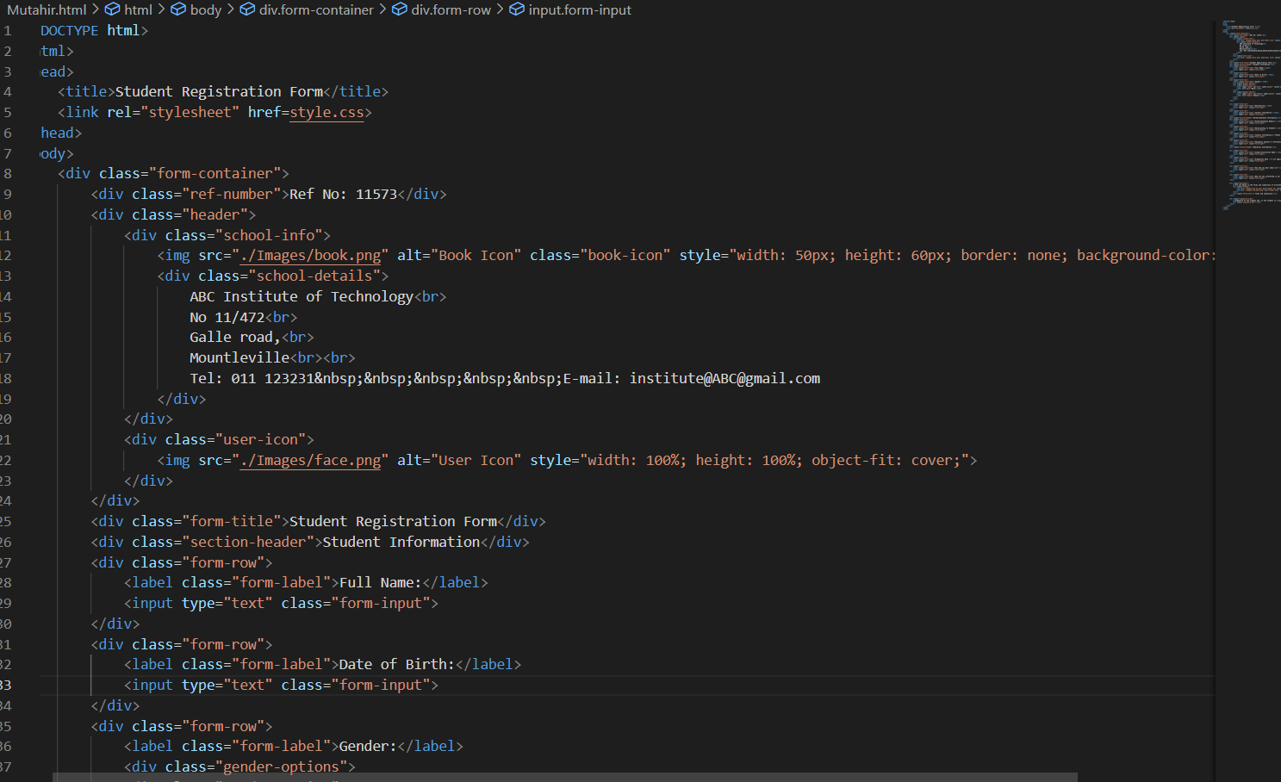

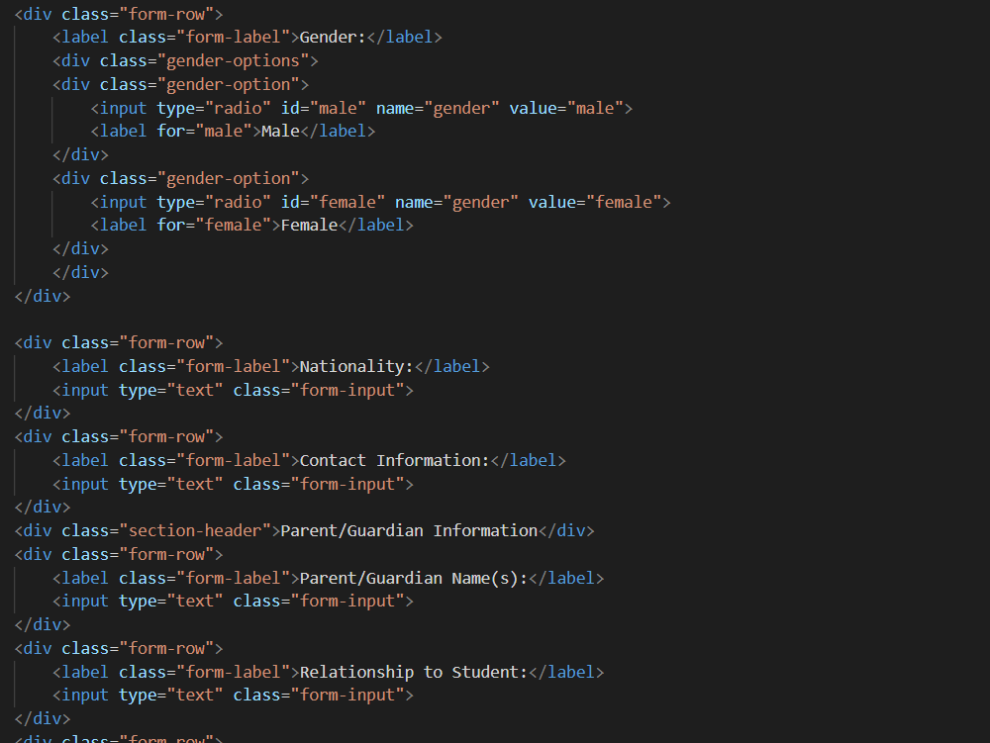

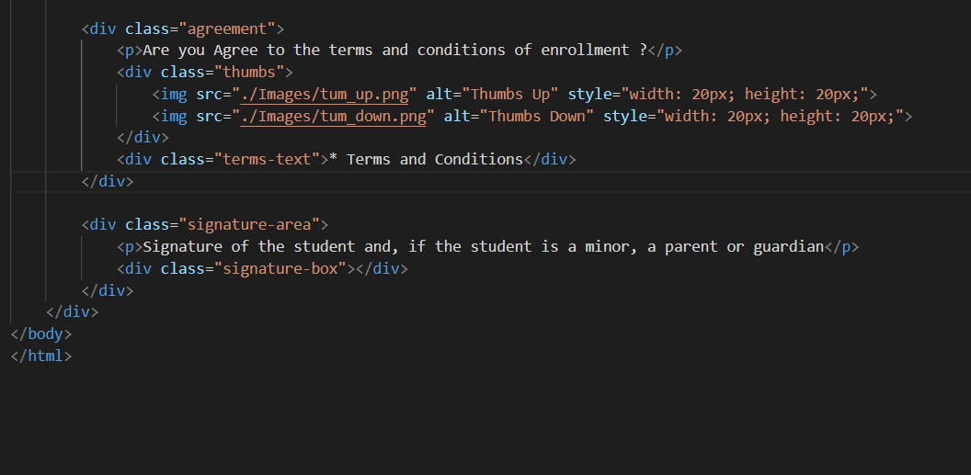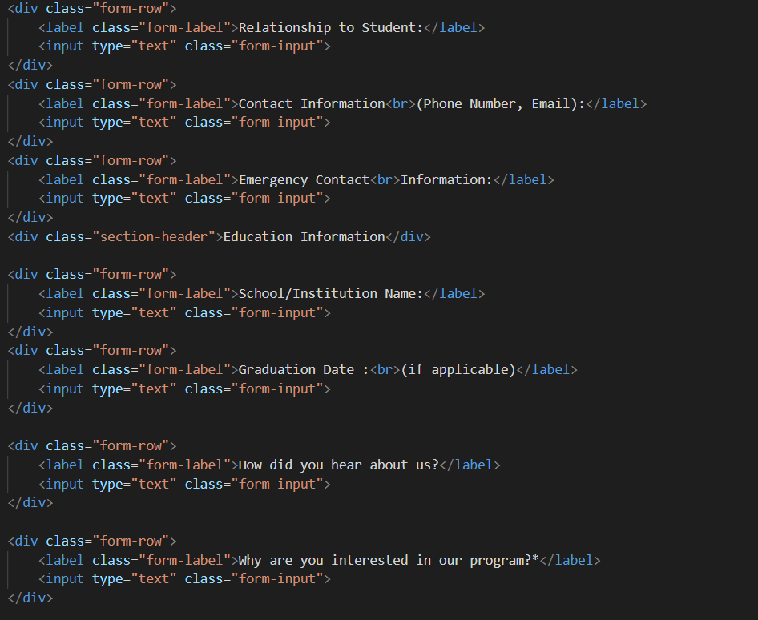

**Style Css:**

body {

font-family: Arial, sans-serif;

padding: 0;

margin: 0;

padding: 20px;

background-color: #fffdf0;

}

.form-container {

max-width: 800px;

margin: 0 auto;

background-color: #fff8e1;

padding: 20px;

border: 1px solid #e6dbb9;

}

.header {

display: flex;

justify-content: space-between;

align-items: flex-start;

margin-bottom: 20px;

}

.school-info {

display: flex;

align-items: flex-start;

}

.book-icon {

width: 50px;

height: 60px;

border: 2px solid #000;

background-color: #ff6347;

margin-right: 15px;

position: relative;

}

.book-icon-stripe {

position: absolute;

top: 20px;

left: 10px;

width: 30px;

height: 15px;

background-color: #fff;

}

.school-details {

font-size: 12px;

line-height: 1.4;

}

.form-title {

text-align: center;

font-size: 24px;

font-weight: bold;

margin: 30px 0;

}

.user-icon {

width: 120px;

height: 120px;

background-color: #ff8c00;

display: flex;

justify-content: center;

align-items: center;

}

.stick-figure {

position: relative;

width: 80px;

height: 80px;

}

.section-header {

background-color: #ff9642;

padding: 8px;

margin: 15px 0;

font-weight: bold;

display: flex;

align-items: center;

max-width: 650px;

}

.section-header:before {

content: "\2022";

margin-right: 10px;

font-size: 20px;

}

.form-row {

margin-bottom: 15px;

display: flex;

align-items: center;

}

.form-label {

width: 150px;

font-size: 14px;

margin-right: 35px;

}

.form-input {

flex: 1;

padding: 8px;

border: 1px solid #ddd;

background-color: #f5f5f5;

box-sizing: border-box;

height: 28px;

}

.gender-options {

display: flex;

gap: 30px;

}

.gender-option {

display: flex;

align-items: center;

}

.gender-option:before {

content: "\2022";

margin-right: 5px;

}

.agreement {

margin: 20px 0;

}

.thumbs {

margin: auto;

display: flex;

gap: 10px;

margin-top: 5px;

}

.terms-text {

font-size: 10px;

margin-top: 5px;

color: #666;

}

.signature-area {

margin-top: 20px;

}

.signature-box {

height: 60px;

width: 170px;

background-color: #ffecb3;

margin-top: 10px;

}

.ref-number {

text-align: right;

font-size: 12px;

color: #666;

}